Membership Update August 2025

Member details 8th September

Senior Team
Details from Ayo on 4th Sept. Membership not recorded on GMS

Sponsored and Paid:
7 Senior Players

Sponsored but not yet paid
10 Senior Players

Not yet Sponsored
12 Senior Players

Junior Section

60 players registered
72 paid memberships – a large number are paid and not registered. Lewis and I are putting together a user guide
25 added parent as social member

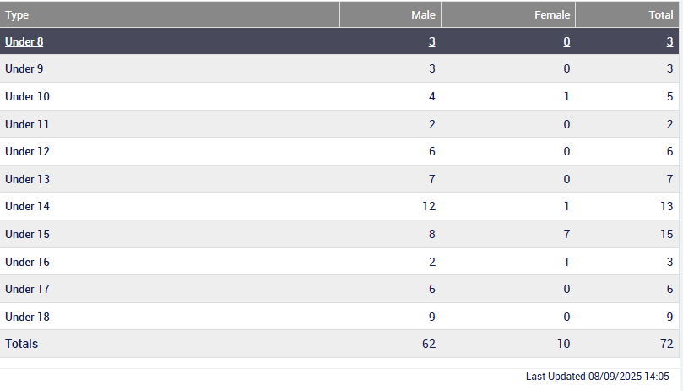

Junior players by area

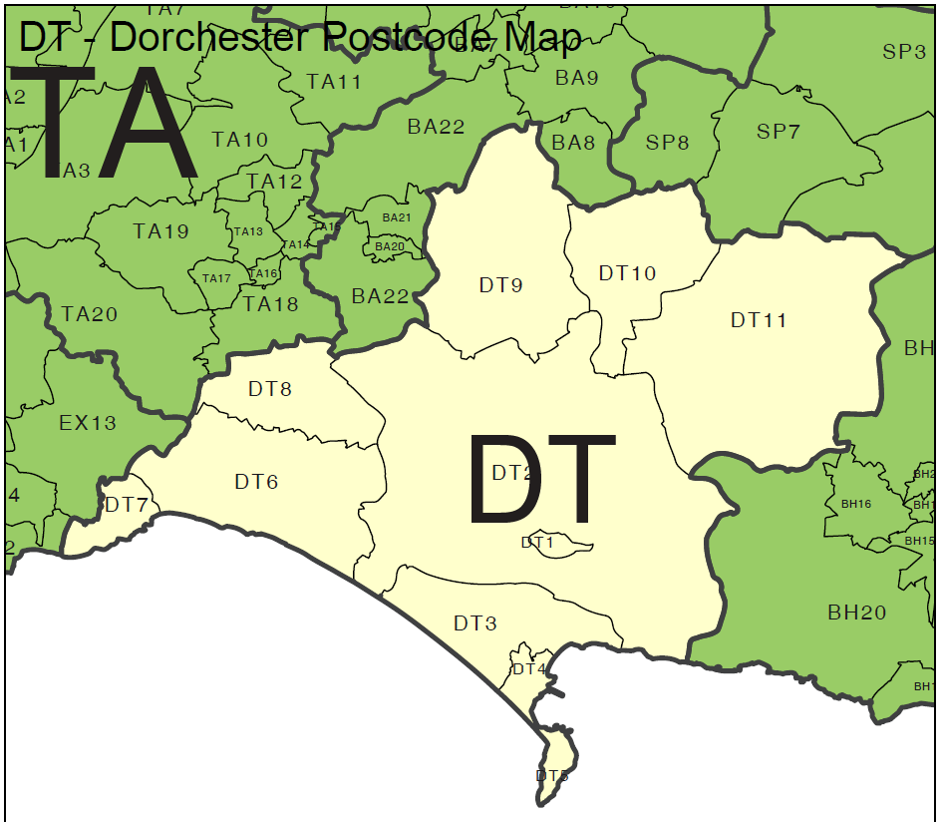

Bridport (DT6) – 44 players
Lyme Regis (DT7) – 9 players
Crewkerne (TA16/18) – 3 players
Axminster (EX13) – 4 players
Maiden Newton (DT2) – 2 players
Beaminster (DT8) – 7 players
Chard (TA20) – 1 player

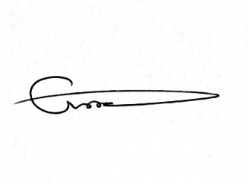
Chris Wood
(Hon) Secretary

